As part of the Diocesan suite of material to help us celebrate “Well-being” Sunday in the middle of January, we were introduced to “The 10 Keys to Happiness”. Ten things we can do to help us stay well; stay motivated; stay healthy. Not just healthy in body, but healthy in mind and spirit as well.

The 10 keys to happiness emerged over a decade ago from clinical and psychological research, which has been supported by literally thousands of research projects. So this isn’t the brainchild of one individual. It’s based on properly researched data.

“The 10 keys to happiness” are now promoted globally by “Action for Happiness” (AfH). This is a non-profit organisation with the stated object of “creating a kinder and happier world”, and it now has over 100,000 members.

“Action for Happiness” points out that Clinical Psychology has tended to concentrate on how to find a cure when things have gone wrong. On top of that our brains are hard-wired to identify risks and problems - that approach was critical to survival. What the 10 keys set out to do are to concentrate our minds on prevention rather than cure; on the positive rather than the negative.

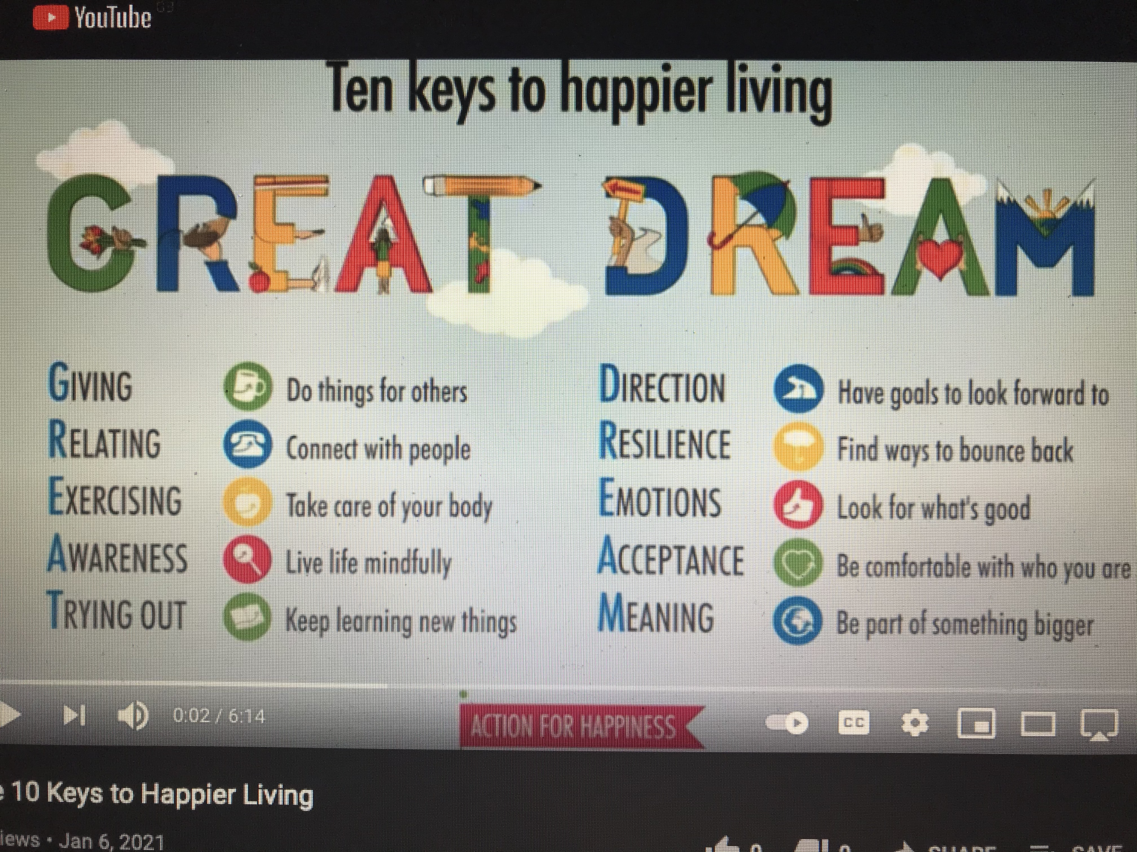
So what are the 10 keys? Here they are.
The initial letters of each key spell out GREAT DREAM. The first 5 are about what affects us from the outside; the next 5 are more about the inside.

What I wanted to explore is how does this psychologically and clinically well researched menu - and AfH describe the list as a menu rather than a prescription- how does it compare with a Biblical perspective? Do we find the 10 keys reflected in the great Bible narratives? Do they align with the way Jesus lives life? How do Jesus’s parables compare? Is there symmetry with The Beatitudes - There is more than one translation that reads “Happy” rather than “Blessed.”

How does GREAT DREAM compare with what Martin Luther King called “God’s dream for mankind.”? With what Pope Francis is writing about in his recently published “Let us Dream - the path to a better future.”

As we look at each of the 10 keys with a “thought for the day”, the plan isn’t to produce something comprehensive - more a taster to whet your appetite, and stimulate your own exploration.

What we may find is that science (or psychology) is much more in tune with Christianity than we are lead to believe. And that the “10 keys to Happiness” are a powerful means to well-being.

